20.24: 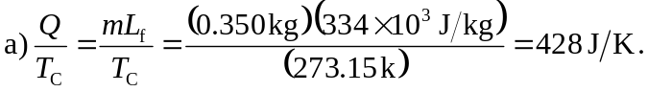
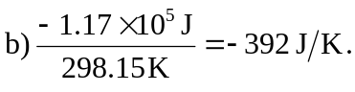
c) (If more figures are kept in the intermediate calculations, or if
